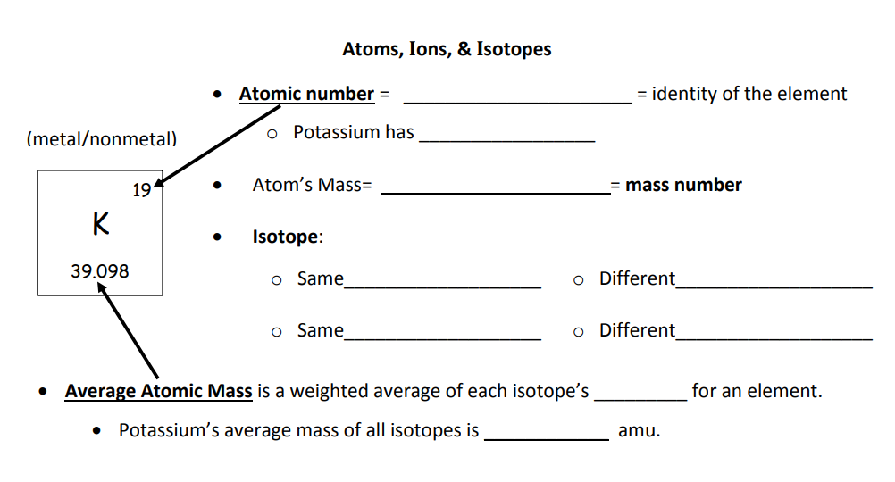
Use the periodic table to complete the table below

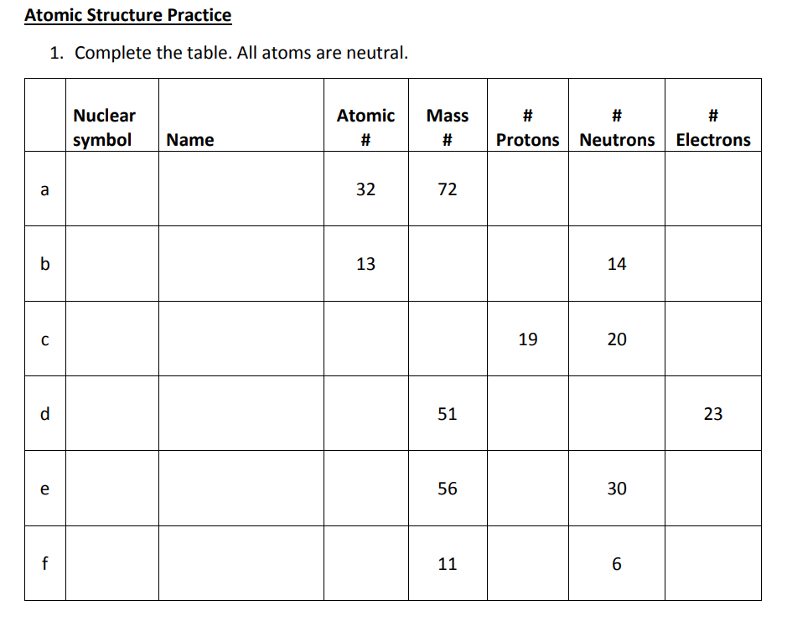

What Are Radioactive Isotopes? | Properties of Matter | Chemistry | FuseSchool

Section 1: The Basics
1. Definition Check
Define the term isotope in terms of subatomic particles. (2 marks)
2. Atomic Structure
An atom of Carbon-12 and an atom of Carbon-14 are isotopes.
- State one similarity in their atomic structure.
- State one difference in their atomic structure.
3. Identifying Isotopes
Look at the table below. Which two atoms are isotopes of each other? Explain your answer.
Atom | Protons | Neutrons | Electrons
A | 8 | 8 | 8
B | 9 | 10 | 9
C | 8 | 10 | 8

